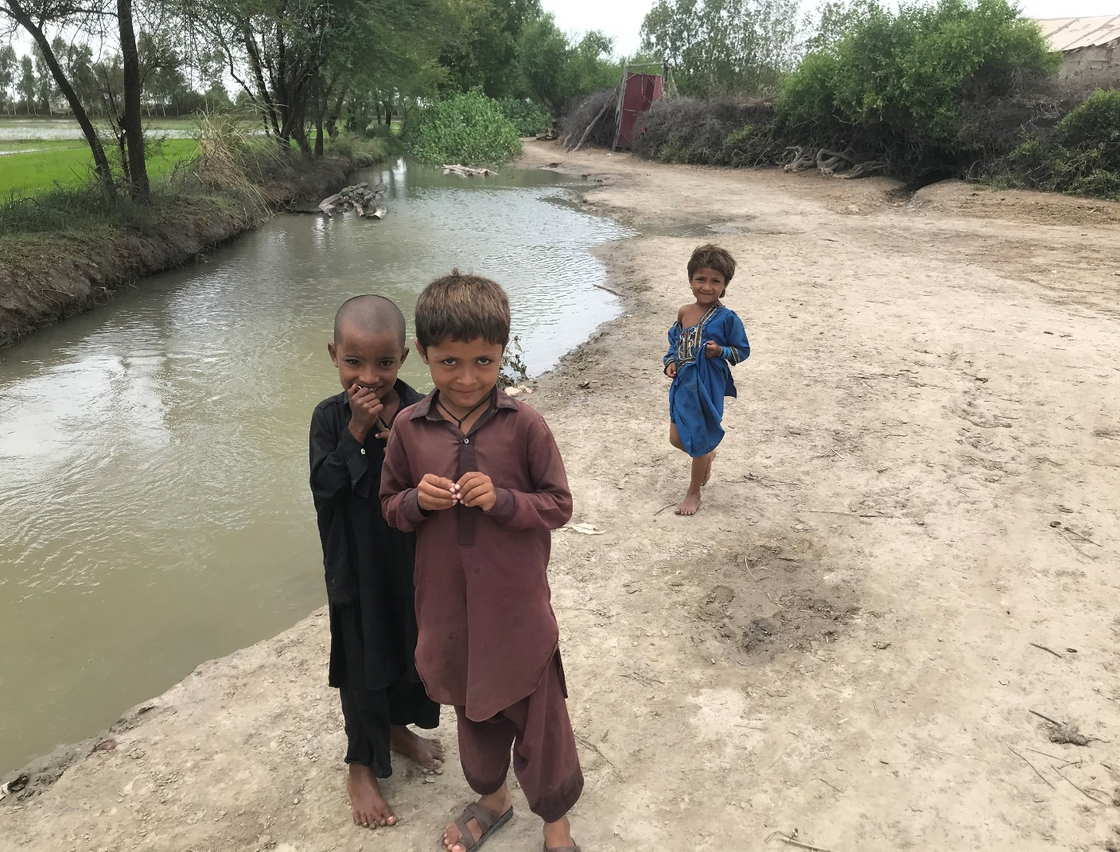**Concept Note**

**Project Title:**

*Sujag /* Literacy and Life Skills for Pakistan’s Out-of-School-Children

**Overview:**

Pakistan has the second-largest out-of-school-children (OOSC) population in the world with over 23 million children out of school. Out of these 23 million, 81% have never attended school and 77% are from rural, remote areas. These areas are usually devoid of basic, operational infrastructural facilities such as electricity, mobile networks, schools, hospitals, roads or clean water.

To reach these children, TCF has developed *Sujag* (meaning “Awakening” in Sindhi), a fifteen-month long literacy and numeracy program for OOSC from the ages of 8 to 16. The program is currently operating in remote villages in the provinces of Sindh and Balochistan. After completing the program, children receive the crucial skills of literacy, numeracy, and a component called “life” skills which include general knowledge concepts on health, environment, and science.

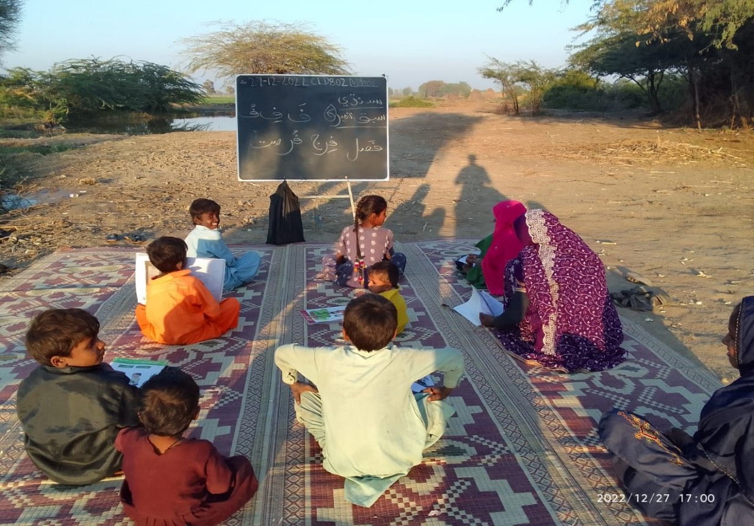

**Objectives:**

* To build cognitive, intrapersonal and interpersonal competencies of OOSC by teaching life, literacy and numeracy skills areas, all of which are locally contextualized based on the children’s surroundings and learning needs, allowing children to transition smoothly from familiar to unfamiliar content
* For literacy, numeracy, and life skills to take root through existing community knowledge

**Beneficiaries:**

To date since 2020, over 11,000 children have been reached through the program. Incommunities where the program is run, the majority of adults are illiterate. Farmers learn to select insecticides and fertilizers based on the aesthetics of the packaging under the guidance of one or two literate members of the community. There are no functional schools for children.

People’s daily routines vary by age and gender. Children usually accompany their mothers during the day to cut grass for livestock (goats, cows, buffalos, and chickens). Men are mostly agricultural workers. Most households lack access to televisions, mobile phones, or even electricity supply.

The communities are insular in nature. While they may be at walking distance from each other, they are closed off from each other. Males beyond a certain age are not allowed to enter other communities. When females reach puberty, they are not allowed to visit other communities unless chaperoned or the visit is need-based.



**Activities:**

As areas in Pakistan are divided into “districts”, the program first conducts data analysis and needs identification to arrive a district-wise OOSC. Districts that have the highest number of OOSC are targeted to conduct the program. A marketing campaign is conducted to spread word about the program in the communities and community members who express interest in the program undergo a screening process which involves ensuring the community has enough children (25 at least) to participate, a teacher who is literate and can be trained to conduct the lessons, a space where the project can be carried out, and no school close by. The individuals who are identified by the communities as potential teachers are eventually called for an in-person, weeklong training.

At the training, aspiring teachers are introduced to the program and its vision, goals and materials which include teacher guides and student workbooks. They are taught pedagogical skills and cover literacy, numeracy and life skills concepts from the program’s curriculum. They are also trained in gathering and reporting student data. At the end of the training, only those who show positive results are selected as teachers for the program and are given the materials required for them to conduct the program in their respective communities. Materials include blackboards, floor mats, school bags, stationery items, teacher guides, student workbooks, storybooks, and teaching aids.

Teachers then conduct the program on the ground by teaching children for three hours, five days a week, for fifteen months. Upon completion of the program, these children acquire literacy, numeracy and essential life skills which pave the way for an improved quality of life for them.

**Monitoring and Evaluation**

Student attendance and progress on lessons is uploaded by teachers regularly on ZOHO forms through teachers’ mobile phones. At Sujag communities or “centers” where low monthly attendance (below 85%) is seen, the teacher’s salary is not processed. At the end of every module, the Annual Status on Education Survey (ASER)’s tool is conducted on students of the program as an assessment of their learning.

**Budget**

The program currently requires PKR 100 million out of PKR 130 million to operate X active centers in Sindh and Balochistan. These result in X children currently enrolled in the program, on their way to gain literacy, numeracy and essential life skills.

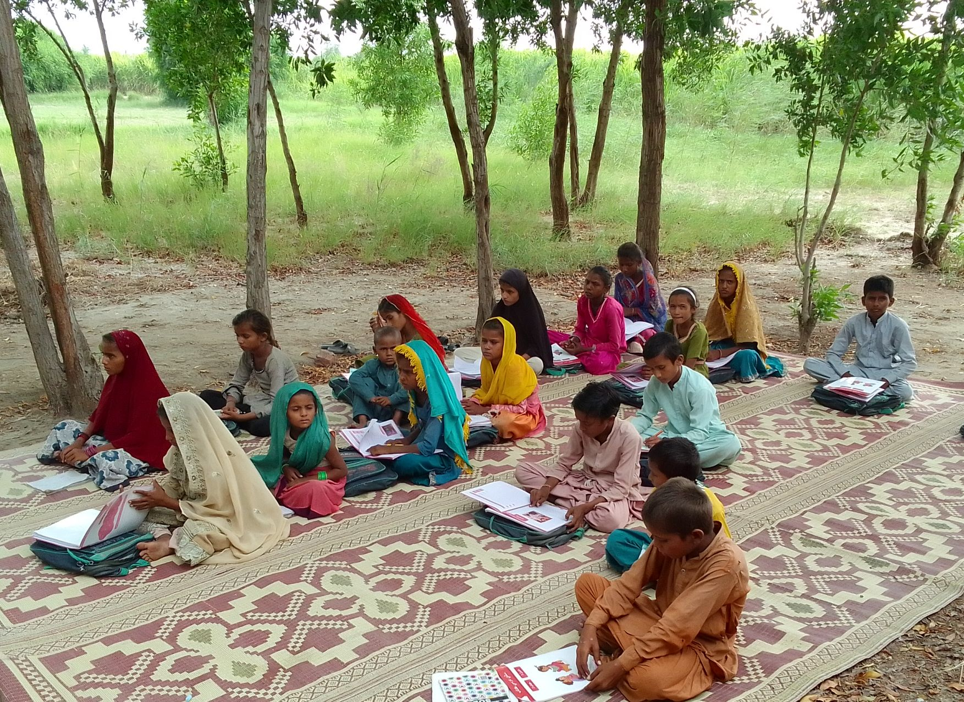Other funders of the program include an Italian foundation, *Fondazione San Zeno*, and a UK charity, The Shirin Sultan Dossa Foundation.