To help tackle Pakistan's current energy crisis, TCF is working towards solar powering 105 schools which have limited access to electricity to ensure uninterrupted learning.

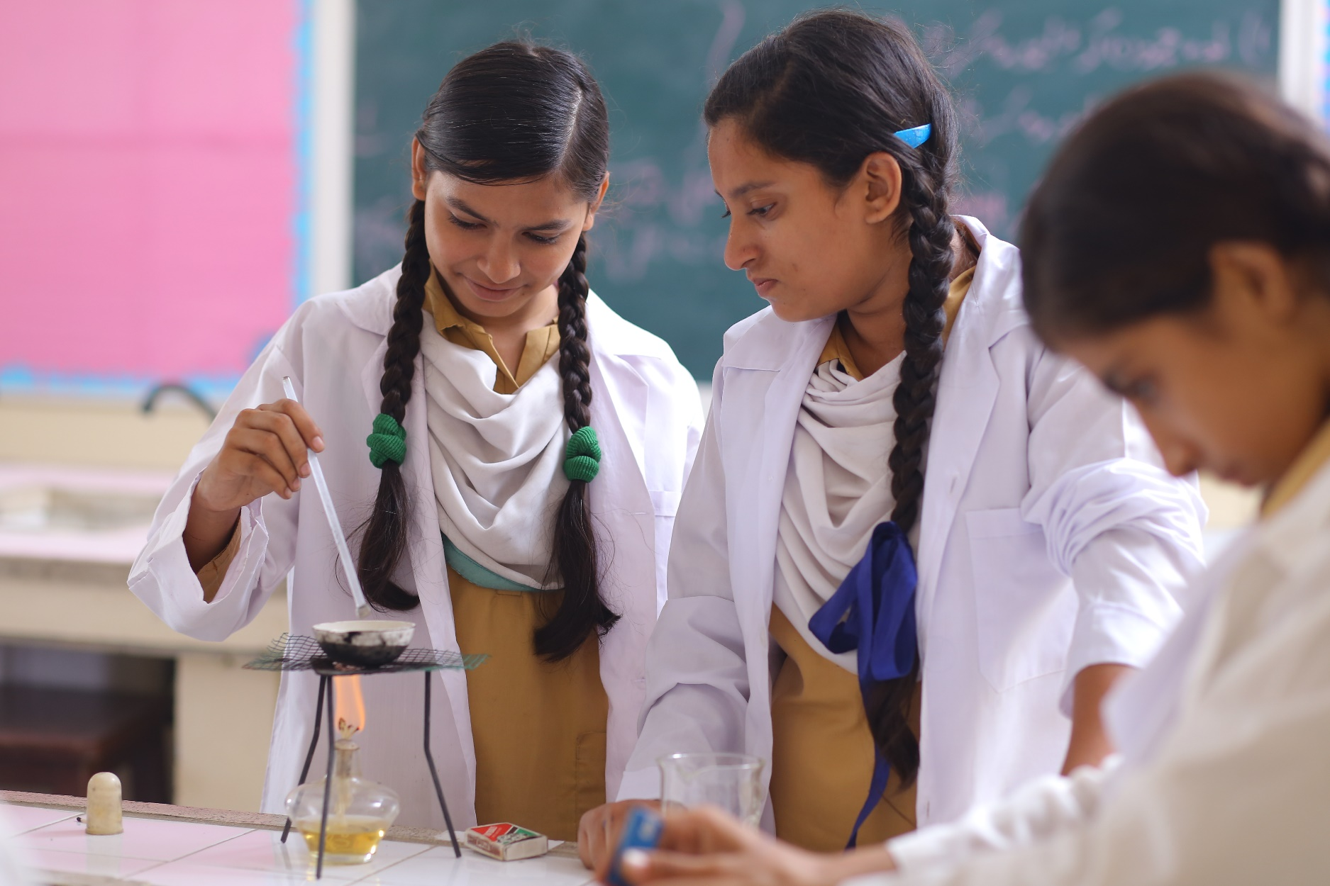

**Enhancing Educational Infrastructure for Secondary Students in TCF Schools**

**To enhance the educational experience of secondary students in TCF schools by establishing modern computer and science laboratories, fostering practical learning and academic excellence.**

**About The Citizens Foundation (TCF)**

With 1,921 schools serving 286,000 students across Pakistan, The Economist has called TCF “[perhaps the largest network of independently run schools in the world](https://www.economist.com/briefing/2018/01/04/pakistan-is-home-to-the-most-frenetic-education-reforms-in-the-world).” TCF focuses on building modern, purpose-built schools in underserved areas, equipped with playgrounds, libraries, and science labs. Its vision is to create agents of positive change: well-rounded individuals capable of breaking the cycle of poverty and contributing to society.

**Context**

In response to post-COVID-19 educational challenges, TCF launched a transformative initiative in 2021 to establish 100 afternoon school shifts. This strategic move addressed the urgent need to transition primary students to secondary education. Rather than investing in new infrastructure, TCF optimally utilized existing resources by introducing afternoon shifts for secondary students within their primary schools. As these secondary students advance to the ninth grade, TCF acknowledges the necessity of equipping these schools with modern facilities to facilitate advanced studies in computer science and the natural sciences. Some campuses require one laboratory, while others demand two or three to cater to diverse educational needs, enriching academic experiences and fostering practical learning and experimentation.

**Project Overview**

The proposed project involves establishing computer and science laboratories in TCF schools with operational afternoon shifts. These labs will meet the growing demand for specialized education in computing and the sciences among secondary students, aiming to enhance education quality through state-of-the-art facilities that promote hands-on learning and scientific inquiry. In appreciation, TCF will honor generous donors by placing plaques in each laboratory, fostering a sense of ownership and pride within the school community. The cost of constructing one lab is $23,000. Every year, TCF identifies several locations where the labs are needed.

**Impact and Sustainability**

The establishment of these laboratories will have a profound impact on the educational experience of TCF students, providing them with opportunities for skill development, innovation, and academic excellence. Furthermore, these facilities will contribute to the long-term sustainability of TCF schools by enhancing their academic reputation and attracting more students to enroll. Through collaborative efforts and generous contributions, TCF aims to empower its students with the resources and opportunities necessary to thrive in an increasingly competitive world.