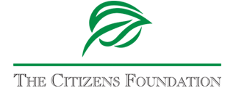

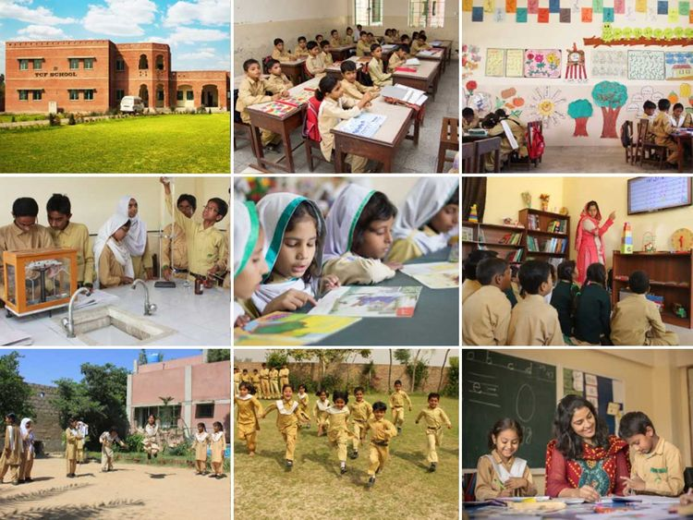

**ENDOWMENT PROPOSAL**

**FOR:**

**DATE:**

# Executive Summary

This proposal is being submitted to request Mr. XXX to create a new endowment Fund in partnership with TCF for an amount of **USD $YYY.** The Endowment Fund aims to provide a reliable income stream to support TCF's operational needs, foster the long-term growth of specified endowments through reinvestment, and incur appropriate and reasonable costs as directed by the Board of Directors. Funds in this endowment will be invested in accordance with TCF investment Policy and will be used for the purpose as specified.

# Management of Funds

The Endowment Fund at TCF is managed by an Investment Management Committee (IMC) comprised of experts from a major asset management company in Pakistan. The committee updates the Board quarterly on the Fund’s performance, following a well-defined Investment Policy approved by the Board. This policy sets benchmarks and guidelines, aiding the IMC in strategic asset allocation and risk management across different market conditions. The fund investments adhere to TCF's investment policy, ensuring responsible management. While generally following this policy, exceptions might be considered with Board approval. Investments are made in institutions rated well by credit agencies PACRA or JCR-VIS. Donors are given the choice between Islamic or conventional investments, aligning the fund with their values. The decision made by donors influences the impact of their donation while upholding financial stewardship, transparency, and accountability.

Recognition:

Your generous donation will be allocated towards your Endowment Fund and will add long-term sustainability to TCF’s education program. It will be a lasting legacy of your belief in Pakistan’s children and Sadqa-e-Jariya towards generations of deserving students.

On behalf of TCF, thank you for your continued support and trust in our mission!

# APPENDIX: Organizational Profile

**Overview**

TCF has been recognized locally and internationally for its innovative approach and contributions to the field of education:

* TCF was awarded the ‘Best Presented Annual Report’ by the eight nation **South Asian Federation of Accountants (SAFA)** for the year 2017.
* **Confucius Prize for Literacy** at the UNESCO Headquarters in Paris for the year 2017.
* The **Schwab Foundation’s 2015 Social Entrepreneur of the Year Award**, which recognizes the organization’s innovative approach towards solving social issues.
* **The Ramon Magsaysay, 2014 Award** for its social vision and its success in proving that quality education can be provided to everyone irrespective of social status, religion, or gender.
* The **Skoll Foundation, 2013 Award for Social Entrepreneurs**.

The Citizens Foundation (TCF) is a platform for change across the educational landscape of Pakistan. It is a non-profit founded in 1995, by a group of friends, with a vision to drive positive change by providing low-cost quality education to the underserved, without any discrimination. Recognized by The Economist as 'perhaps the largest network of independently run schools in the world', TCF is educating 286,000 students in 1,921 school units across 64 districts of Pakistan, with over 20,000 employees including an all-female faculty of 14,000 teachers and principals. This inclusive approach plays a pivotal role in encouraging parents to send their daughters to school, as TCF remains committed to maintaining a gender balance in its classrooms.

To provide easy access to marginalized, low income and often conflict prone neighborhoods of the country, TCF schools are embedded in the heart of the communities they serve. All TCF schools are landmarks in their communities, and are often within walking distance of children. Each TCF school unit is purpose-built and well-equipped with airy and well-lit classrooms, an administrative block, playground, library, and computer and science labs to provide students with a stimulating learning environment. Infrastructural facilities such as toilets, running water, and electricity, are also provided.

Prior to the construction of any TCF school, a comprehensive site survey is conducted to evaluate the socioeconomic conditions of the community. This assessment also ensures that existing schools are equipped with the necessary capacity and are within affordable means for the children of the community. TCF is deeply committed to making education accessible and affordable, heavily subsidizing the cost of education through need-based scholarships. As a result, some parents pay as little as 20 rupees (USD XXX), in addition to receiving further support such as free books and uniforms.

TCF imparts 21st-century learning through its innovative education model. It enables its alumni to access higher education opportunities and collaborates with the Governments to improve outcomes in the public sector. TCF also develops communities around its schools by empowering them with literacy, life skills and work readiness competencies. By sharing its programme, experience and capabilities of 28 years, TCF enables stakeholders within the education ecosystem to improve outcomes.

**Faculty and Non-Faculty Staff**

To encourage female enrollment, TCF employs female only faculty and provides them with pick and drop facility as a benefit. Each faculty staff member goes through extensive pre-service training and annual developmental training to update their knowledge and equip them with the latest teaching skills. Members of the local community will also be given employment in non-faculty positions of accounts’ assistant, van driver, guard and maid.

**TCF’s Holistic Approach to Educational Excellence**

TCF schools are an integral part of a robust support system, benefiting from the Head Office, Regional Offices, and the dedication of Principals. These elements collectively provide clear guidance and support. Regional Offices maintain active connections with schools through monitoring, while Principals play a pivotal role in school management, overseeing teachers and operations.

At TCF, our relentless pursuit of educational excellence is further fortified by robust management control systems. The Academics Department meticulously oversees our dedication to excellence, ensuring that we adhere to the curricula defined by the Federal Board, enriched with our own thoughtfully crafted textbooks and learning materials. This commitment extends to the professional development of our teaching staff, with over 100 hours of annual training dedicated to honing their skills and ensuring the delivery of high-quality education."

Recognizing that the quality of our education is a direct reflection of our educators, TCF conducts extensive teacher and principal training programs each year. These programs are thoughtfully designed based on comprehensive training needs assessments, covering a wide range of subjects, pedagogy, assessments, early childhood education, character development, and critical thinking. Additionally, TCF principals receive specialized training in effective leadership and management practices.

In our unwavering quest to deliver holistic education, TCF has introduced innovative programs to develop students' skills and nurture their love for learning. Our Early Years Programme, based on global best practices, fosters essential 21st-century skills and the joy of learning through play, captivating stories, reflection, and hands-on activities led by the students themselves.

Moreover, TCF is committed to equipping students with digital-age skills through our cutting-edge Digital Literacy Programme. This initiative offers contemporary curriculum and access to modern digital technologies, sparking interest in Computer Science, and imparting knowledge about digital citizenship.

TCF has also designed and implemented a Mother Tongue Based Multilingual Education (MTB-MLE) model in our schools in Tharparkar, Sindh, where children in their early years are being taught in their mother tongue. This model is being implemented based on a three-year research study carried out by TCF, which concluded that using familiar languages in the early years of learning and then gradually introducing foreign languages maximizes comprehension and fluency.

By interlinking the management and support systems with our commitment to teacher and principal training, initiatives based on research and development, TCF creates a comprehensive framework for educational excellence that ensures the bright futures of our students and a transformative impact on the communities we serve.