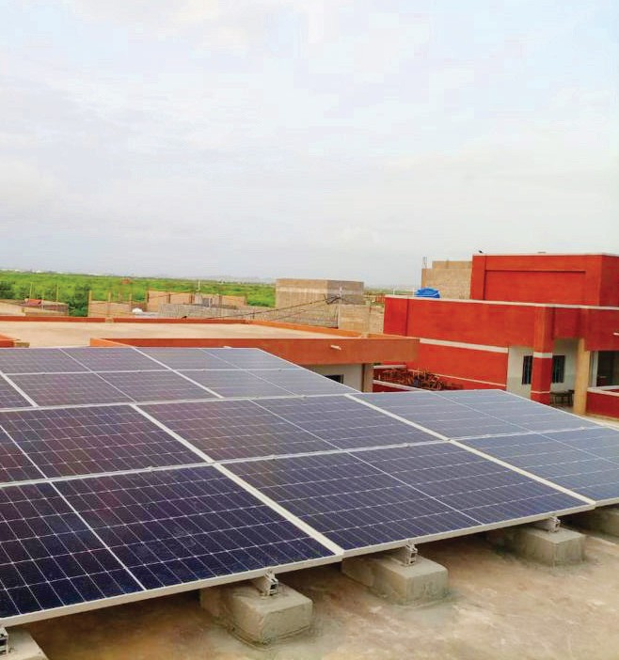


To help tackle Pakistan's current energy crisis, TCF is working towards solar powering 105 schools which have limited access to electricity to ensure uninterrupted learning.

Promoting Access to Solar Energy at TCF schools

To help tackle Pakistan's current energy crisis, TCF is working towards solar powering 86 schools which have limited access to electricity to ensure uninterrupted learning.

About The Citizens Foundation
With 1,921 schools serving 286,000 students across Pakistan, The Economist has called TCF “perhaps the largest network of independently run schools in the world.” TCF builds and operates schools in Pakistan’s most underserved urban slums and rural areas where access to quality education is limited or non-existent. TCF schools are not ‘poor schools for poor children". They are modern, purpose-built schools complete with playgrounds, libraries, and science labs.

TCF’s vision is to create agents of positive change: well-rounded, motivated, and capable individuals who will not only be able to steer themselves and their families out of poverty but also seek to improve the future of their communities and society at large.
Context
TCF has 1,921 schools all over Pakistan. A burgeoning population across the country coupled with poor infrastructure and an energy crisis make delivering quality education a challenge, especially for a network like TCF. It is for this reason that TCF has decided to integrate solar infrastructure into construction plans and budgets for all new schools. Schools with older construction lack this integration.
TCF schools have a higher gender parity than the national average because parents know these schools are equipped with adequate facilities, making them safe spaces for children. This includes ensuring schools have an all-female faculty and a proper campus with boundary walls, running water, and toilets.
TCF has identified 110 schools in its network that have no electricity or are suffering from long power outages and would benefit from solar powered energy. Providing these TCF schools with access to electricity will allow for continuity of education and ensure that students’ learning is not disrupted due to infrastructural challenges.​
Project Need
Insufficient access to energy has severe repercussions, particularly in the educational realm, significantly diminishing the available teaching resources and classroom materials. The absence of electricity restricts students in completing assignments, limiting access to current information. Teachers face challenges in reproducing school materials, connecting to the internet for research, and accessing online educational content like videos and multimedia resources. Consequently, the quality of education suffers, depriving students of the learning experience they rightfully deserve.
The impact of energy poverty also extends to the recruitment of qualified teachers, discouraging them from working in areas lacking electricity. The absence of essential amenities like electric lighting, computers, and televisions deters skilled educators from contributing to communities that need their expertise the most.
Children in energy-deprived areas often find themselves prioritizing household responsibilities over attending classes or completing assignments. This results in reduced school attendance and hampers their academic progress.
Moreover, the lack of a stable supply of electricity also affects the health and hygiene of students at TCF schools as schools are reliant on energy to use water pumps thereby disrupting water supply to schools for sanitary use. Schools are also unable to operate water filters and dispensers which in turn affect the supply of drinking water at TCF schools as well.
Introducing alternative energy sources, devices, or solar-powered solutions can alleviate these challenges, creating more study time for children.
Bringing electricity to schools not only facilitates the integration of information and communication technologies (ICT), including phones, televisions, computers, and the internet but also positively impacts overall school functioning. Reports from UNESCO highlight the transformative effects of ICT on schools, improving student achievement, enhancing access to education, increasing efficiency, reducing costs, fostering lifelong learning, and preparing students for a competitive global workforce.
Beyond its impact on students, access to electricity attracts and retains teachers, leading to improved training opportunities and the adoption of advanced teaching techniques. Schools equipped with adequate access to electricity schools contribute to a holistic learning experience, benefitting both students and educators alike.
Operations, Monitoring and Maintenance
- TCF liaises with credible 3rd party vendors to procure and install solar panels at each school. Solar panels are assembled locally with batteries for backup.
- The ongoing monitoring and maintenance of these solar panels will be managed by TCF’s engineering department, who will conduct frequent visits along with contractors/vendors to ensure the panels are operational and working efficiently.
- Payments will be released to contractors once the monitoring team verifies that the panels have been installed according to the defined terms and conditions of the agreement.
- The entire process of solarizing one school from vetting and finalizing vendors to signing contracts and installing solar panels takes approximately 12 weeks.
Current Funding Requirements
- The cost of installing one 8KW system solar panel is estimated to be around $8,500/-
- Currently, out of 110 TCF School units that were identified as having no access to electricity, we still need funding to equip 86 School units with solar power.
- The total funding requirement to solarize 86 school units is $731,000/- which will serve 30,960 students.
Costs of solar panels may vary due to inflation, reduction in subsidies to solar companies, and introduction of taxes.

