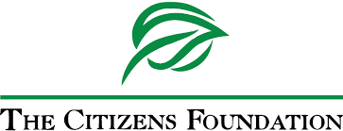

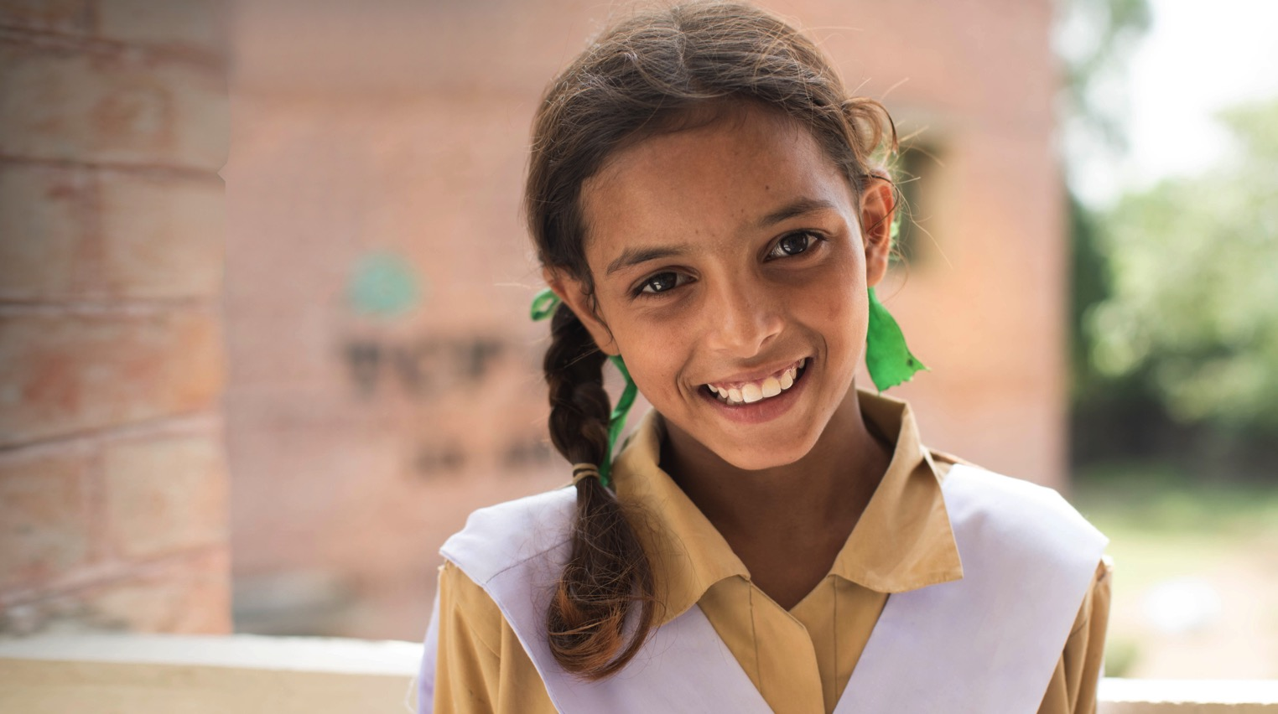

**Proposal for Support to The Citizens Foundation**

21st March, 2024

# The Learning Crisis in Pakistan

Pakistan has the fifth largest population in the world and the second largest out of school population. 23 million children with the ages of 5-16 years do not go to school, representing 44 % of the total population in this age group. 40% of children in Pakistan today go to private schools but the quality of learning is poor. Among those in school, less than half can read a sentence in a local language.

# The Citizens Foundation

The Economist has called The Citizens Foundation (TCF) "perhaps the largest network of independently run schools in the world." TCF at present has 1833 school units with 280,000 students. Over 53,000 TCF students have matriculated to date and have been empowered through education. Since its inception, the Foundation has become the largest private employer of women in Pakistan, with an all-female faculty of 13,000 teachers and principals.

# The TCF Story

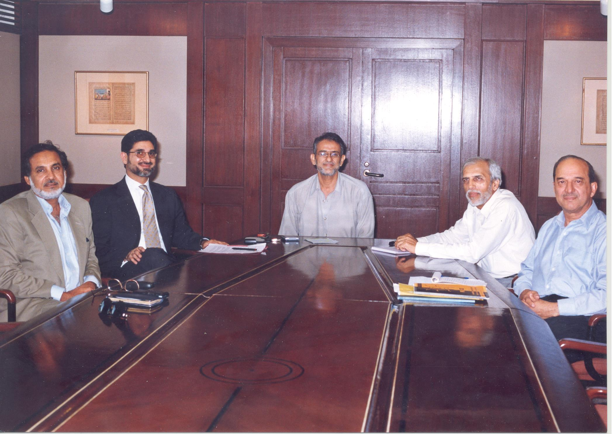The Economist has called The Citizens Foundation (TCF) "perhaps the largest network of independently run schools in the world." TCF at present has 1,833 school units with 280,000 students. This journey started in 1995, when six friends came together to confront a question: What can we do, as citizens, to address Pakistan’s myriad crises? After considering multiple forms of intervention across various social sectors, the group eventually agreed on a plan. They would leverage their experience of building companies to create a network of 1,000 schools for the country’s poorest children.

These schools would not be ‘poor schools for poor children.’ The founders believed that poor children should go to schools like the ones that they and the world’s privileged populations had access to. The group put their own money into a pilot to build five schools in Karachi’s slums that did not have electricity, sanitation, and clean water. Rising out of the heaps of trash, the schools were each an oasis.

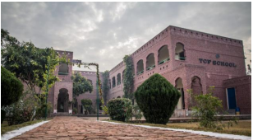TCF chose to embed purpose-built schools in the heart of communities, so children could walk to school. Focusing on intensive training for their school leaders and teachers, developing world-class textbooks, teacher guides and digital content based on global research and building an integrated system of assessments and quality assurance, TCF aims to provide quality education in the most challenging and remote communities. Ensuring an all-female faculty helps maintain a 50% female student ratio and makes TCF the largest private-sector employer of women. TCF continues to support its 53,000+ alumni throughout their academic and professional journeys with information, counselling, development opportunities and financial support. Community development programmes such as the Aagahi Adult Literacy programme (which has helped 160,000+ women graduate to basic literacy), help uplift the communities around our schools. Due to its professional management and on-ground impact, TCF has received global recognition such as the UNESCO Confucius Prize for Literacy, Schwab Social Entrepreneur of the year, the Ramon Magsaysay Award, Skoll Social Entrepreneurship Award as well as Qatar Foundation’s WISE Award

**Supporting 11 Existing TCF Schools**

**Overview**

For academic year (2023-2024), annual operational cost is estimated to be USD 22,000 per TCF school unit. All TCF Schools have a pay-as-you-can-afford system, where families are encouraged to make a nominal contribution towards the fee based on their means – often as little as 8 cents (PKR 20).

School operations in the following 11 school units are currently unsupported for the academic year 2023-24 and we request a contribution of **USD 242,000** to help sustain these operations.

|  |  |  |  |  |
| --- | --- | --- | --- | --- |
| **Campus Name** | **Location** | **Start Year** | **School Unit** | **Funding request (USD)** |

**Donor Recognition**

A Supporters’ Board is installed inside the Principal’s office. Every time a donor funds operational deficit for a school, a Supporter’s Strip is added to the board. In addition to this, a wooden plaque is also placed in the campus bearing the text specified by the donor for that respective year.

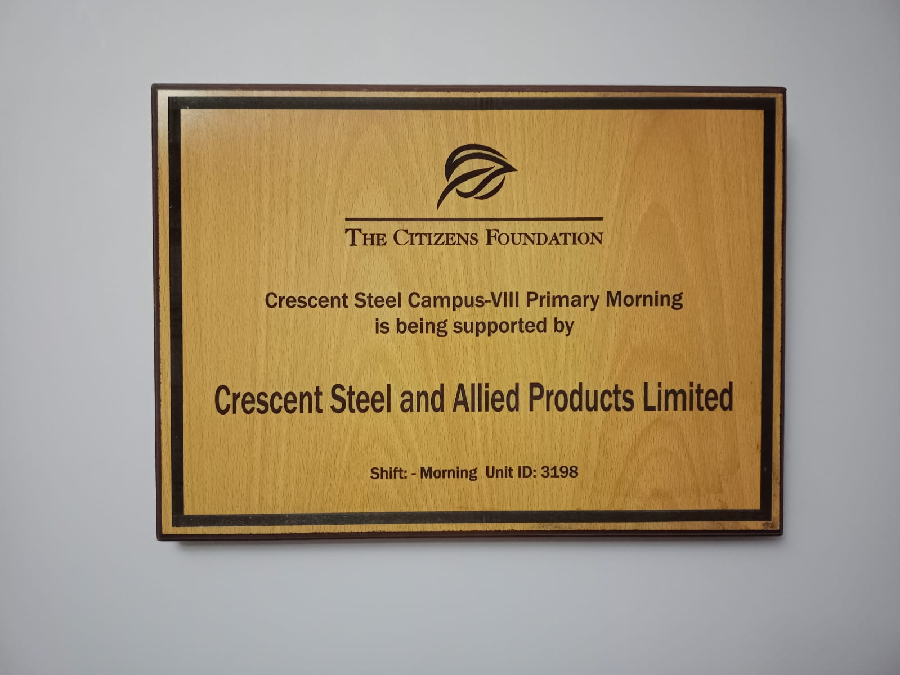 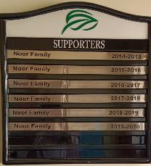

**Wooden Plaque Supporter Strip**