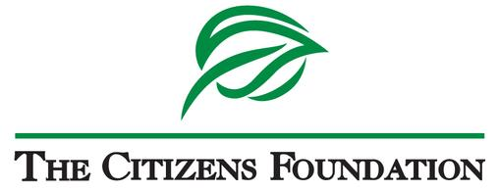

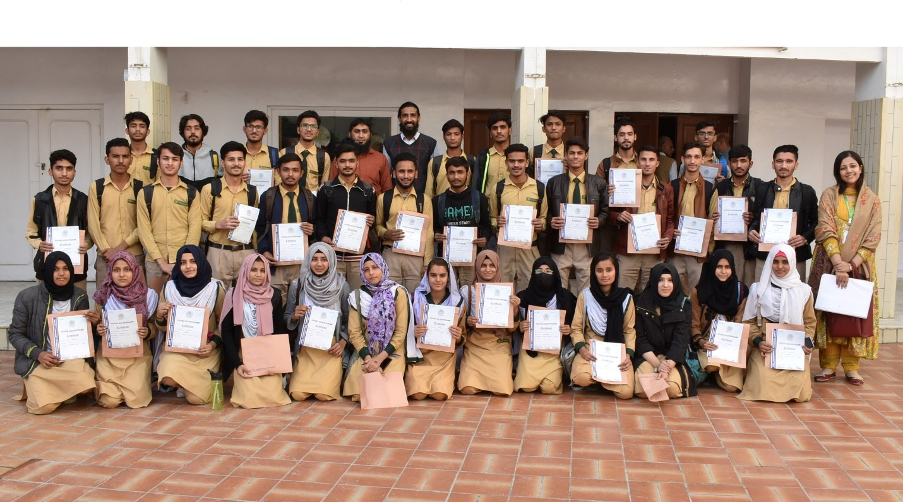

**Proposal Title:**

**Empowering TCF Alumni through Higher Education and 21st-Century Employability Skills**

**Organization:**

**The Citizens Foundation**

**Website:** [**https://www.tcf.org.pk/**](https://www.tcf.org.pk/) **E:** [**grants@tcf.org.pk**](mailto:grants@tcf.org.pk)

**The Citizens Foundation | Plot #20, Sector 14, Korangi Industrial Zone, Karachi, Pakistan**

**Contact Person:**

**Maheen Mirza, Senior Manager Global Partnerships, E:**[**maheen.mirza@tcf.org.pk**](mailto:maheen.mirza@tcf.org.pk)

**Submitted to:**

**Name of the Donor**

*Date:*

**Context:**

The Citizens Foundation (TCF) is a professionally managed, non-profit organization set up in 1995 by a group of citizens who wanted to bring about positive social change through education. 28 years later, TCF is one of Pakistan’s leading organizations in the field of education for the less privileged. TCF schools end at tenth grade, which is the same as the public school system. While a majority of students graduate and try to continue to higher secondary schooling, many TCF alumni drop out in these years and never make it to university. Barriers to staying in school include expensive transportation (because higher secondary schools are fewer in number and farther away), a change in the language of instruction from Urdu to English, and classes not being held regularly in government institutions, resulting in students having to pay for expensive tutoring.

Even when students transition to university, employers find graduates from the country’s top universities lacking in employability skills, such as oral and written communication, critical thinking, teamwork, problem-solving, and digital skills. Most colleges or coaching centers for intermediate education are focused on only covering academic content, ensuring students get the necessary grades to transition to higher education. This makes students ill-equipped as many do not understand the content they are studying. They are only learning to pass an exam, and lack basic, essential employability and life skills.

TCF established its first college in 2016, in Karachi. The college has been able to fill a critical gap for TCF alumni, ensuring some are able to transition to higher education. The College focuses on providing quality academic instruction augmenting the student experience through IT and research skills, improving English proficiency, career counselling, and personal mentoring sessions. TCF College ranks #4 in Karachi based on scores in Board of Intermediate Education Karachi.

Currently, there are 498 students enrolled in the college of which 277 are enrolled in Intermediate-I and 221 in Intermediate-II with 55% of girls and 45% boys. As a bridging institution for tertiary education, TCF College has improved the number of students transitioning to universities over the years i.e. from 65% in past to 80% in 2022. Since its inception, over 797 students have progressed to University education. TCF College (TCFC) has seen an 83% transition to tertiary admissions year on year.

**About TCF College**

TCF aims for all students enrolled at the college to develop strong employability skills in the form of professional communication, interpersonal, problem-solving, leadership, entrepreneurship, and digital literacy skills, as well as confidence and global awareness. The College program comprises of 3 distinct specialties.

1. **Academics**

Offering pre-engineering coursework, TCF College focuses on providing the best academic experience for students. With a 6 day work week, students receive 870 hours of academic instruction during their time at the college, which is nearly double the hours offered by Government Colleges. The passing rate at TCFC is 100% with over 70% students scoring “A” grade. The College has a stringent recruitment process, ensuring that teachers with the best pedagogical skills, content knowledge and a commitment towards education and their students are brought on board and retained.

This year the TCF College has introduced its pre-medical stream. This decision was made alongside the transition to the federal board curriculum. Offering this stream will open up new pathways for the students who aspire to pursue careers in the medical field. By providing them with the best opportunities, TCF aims to ensure they have a fair chance in the highly competitive applications to medical universities. Currently, the college has admitted its first batch of 52 young, aspiring medical students that includes 40 girls and 12 boys.

1. **Personal Development**

Students at TCFC mostly belong to modest or impoverished backgrounds with little means for self-development and few experiences outside their inner circle. The College program develops students to present themselves in the most positive light and increase their overall confidence. Students are taught research skills, presentation, public speaking and group work. Guest speakers are invited to speak about topics ranging from career choices, to discussing religion and sociology. University visits are also arranged for students to explore and seek guidance on various degree and scholarship programs. Students are also provided opportunities to participate in workshops including theatre, clay and pottery, public speaking, graphic designing, cooking and baking, photography, architecture, robotics, and self-grooming. Students spend 300 hours in personal development activities during their 2-year tenure at the college.

1. **University Test Preparation**

Special focus is given for University admission tests’ preparation. 500 hours are dedicated to students learning how to write their resumes and application letters, improve their spoken and written English and attempt various tests including SATs. This is double the time spent on test preparation compared to competitive test preparation centers.

Additionally, a new programme currently titled “2+1” has been introduced to support 5 students graduating from the college. These students presented great potential during their 2 years at the college but due to circumstances, were unable to receive admissions to the best Universities in Pakistan. With additional grooming and coaching, the College team anticipates that these students will be able to secure positions in the best Universities in the next year. Students are kept engaged as Teaching Assistants and Student leaders during this “Development Year” and are paid for this position. This ensures continuing support for students’ education from parents who are eager to see their children become earning members of the household due to strained financial capacities.

TCF College has been able to maintain a higher ratio of girls enrolled at the college because of its transport facility. Given the rise in inflation and fuel costs, providing transportation to students that come from all parts of Karachi ensures attendance and enrollment as these students come from underprivileged backgrounds and cannot afford this recurrent cost.

Students start applying to Universities starting from January every year. 155+ students from the 2021-22 cohort obtained admissions in prestigious universities across Pakistan. From the 2022-23 batch, the admissions process is currently underway.

**TCF College Calendar Activities:**

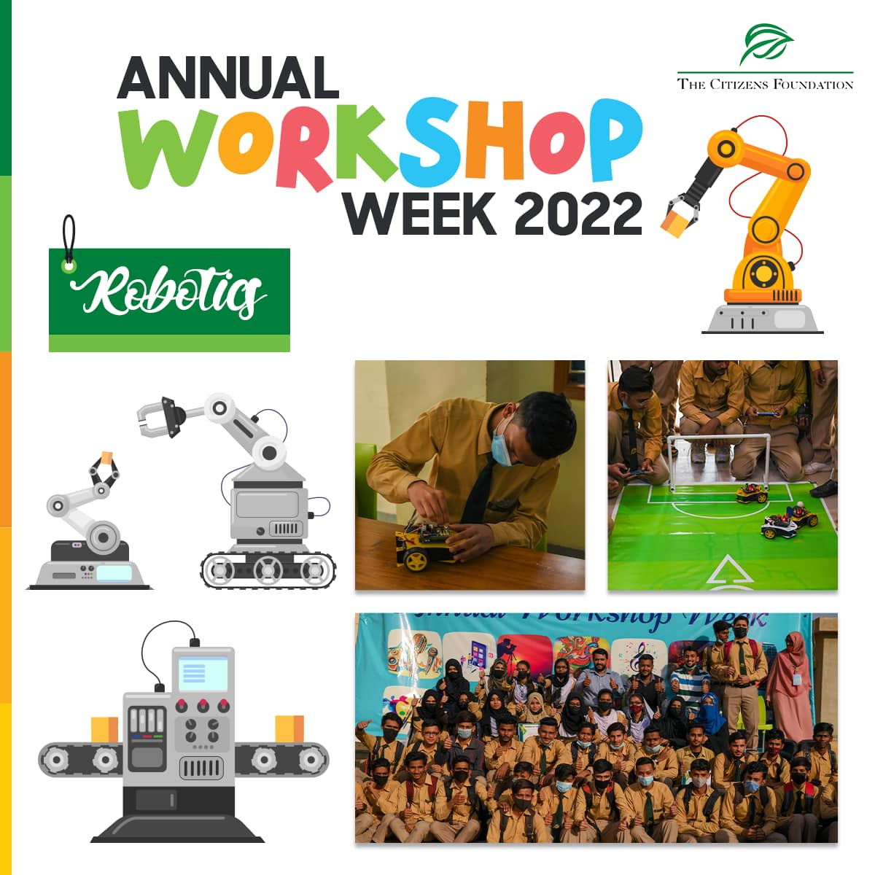 Every year the college invites TCF students for the annual admissions in December. The college conducts a vigorous process to ensure merit-based admissions; highly transparent, all-inclusive, and merit-based without any gender preference/quota. The shortlisted and reserved candidates are invited to the Selection Camp in June which is a one-day activity. The selection camp is the second phase of shortlisting where candidates undergo different activities such as IQ tests, interviews, panel discussions, etc. Following the Selection Camp, a Parental Engagement session is held prior to finalizing admissions to ensure that parents understand the demands of the College and the commitment required. For the new academic year 2023-2024, 277 students are offered admission.

*At TCF College, students are provided a holistic learning environment that contributes in their cognitive development.*

Students start their journey at TCF College at the end of June with an Orientation and a Foundation Camp. The Foundation Camp for first-year students focuses on strengthening English language proficiency since most students have been schooling in Urdu up to this point and must now transition to learning a foreign language. The Camp also focuses on strengthening Math skills. This period also tests students’ attendance, grit, and resilience to continue in the demanding college routine.

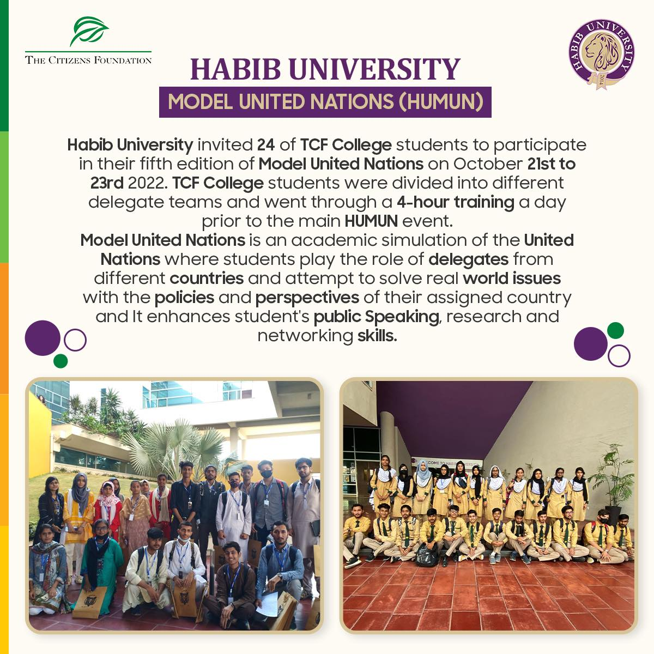Right from the onset, the college trains students to achieve excellent results both in academics and extra-curricular activities. College enables students to transition to tertiary education and secure employment through outcome-oriented student development activities that take place round the year from August to May along with regular academic sessions. These activities equip students with the 5-Cs of 21st-century skills (Creativity and Critical Thinking, Conceptual Understanding, Confidence, and Communication). The student activities revolve around 6 main thematic areas i.e. Student Week/Winter Workshop, Career Choice/Development, Expanding World Views, Life Orientation, Digital Literacy Skills, and, Computer Science & Engineering.

*TCF College students are encouraged to participate in various public speaking events. For example, TCF College students participated in Model United Nations at Habib University, Karachi*

Along with self-development activities, students are prepared for their board examination from Day-1. Each student receives 800+ hours of training to prepare for exams. Midterm examinations are rolled out in December whereas Final Board Examination takes place in May-June.

The college also offers internship positions to college alumni after they graduate from TCFC which helps them to grow professionally. Each year 10 student leaders and 2 interns are hired by the college on a rolling basis.

**Request for Funding:**

The devaluation of the Pakistani Rupee in the global market poses a challenging scenario for the approaching year. The expenses tied to paper and fuel have seen a doubling effect compared to the previous year, and the need to accommodate compensation in salaries amidst escalating inflation adds further complexity to the budgeting process for forthcoming expenditures. The budget for the college for the academic year **2023-2024** is **USD 360,000**. For the mentioned academic year, we humbly appeal for your support of **X USD**. Your contribution would make a significant difference in ensuring the continued success of the TCF College.

The table below shows a breakdown of the annual college costs.

|  |  |
| --- | --- |
| **Cost Break-up** | **Amount (USD)** |
| Student Transport | 147,500 |
| Student Materials (Books, Printouts, Uniform, Stationery) | 23,500 |
| All Other Operational Costs for College | 42,000 |
| Teacher Salaries | 109,000 |
| Head Office Operational Expenses | 38,000 |
| **Total Cost** | **360,000** |

**Reporting Timeline:**

TCF will be sharing bi-annual reports on your annual support on the below timelines:

31st March 2024 – for the period July – December 2023

31st August 2024 – for the period January to June 2024