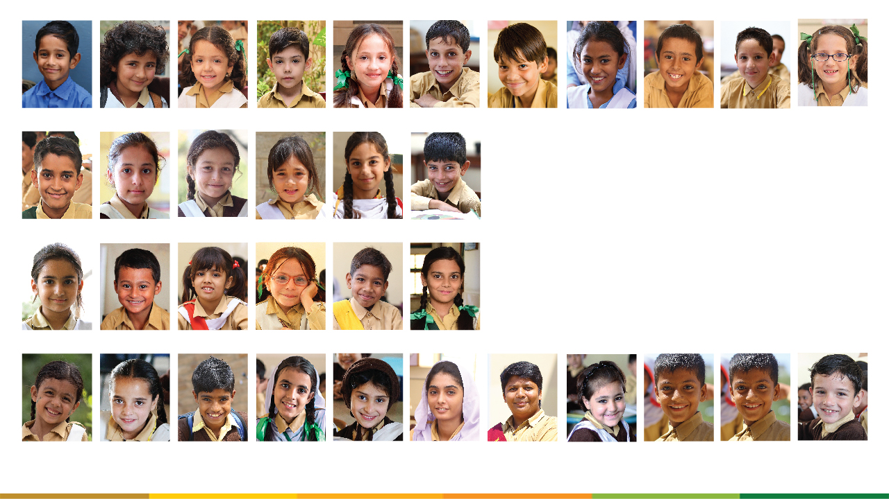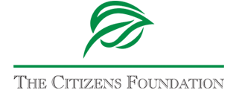

Submitted by: The Citizens Foundation  
Website: <https://www.tcf.org.pk/> Email: [grants@tcf.org.pk](mailto:grants@tcf.org.pk)

Contact Person: Maheen Mirza, Senior Manager Global Partnerships, Email: [maheen.mirza@tcf.org.pk](mailto:maheen.mirza@tcf.org.pk)

The Citizens Foundation | Plot #20, Sector 14, Korangi Industrial Zone, Karachi, Pakistan

**TERTIARY SCHOLARSHIP PROPOSAL 2023**

**For: Mr. Zia Bhatti**

**7th August, 2023**

**About the Tertiary Scholarship**

The Citizens Foundation (TCF) strives to support deserving TCF Alumni who obtain admission at credible institutions for Tertiary Education (4-to-5-year degrees). The aim is to offer them the same opportunities for education and employability as a student from an advantaged financial background. TCF believes that with the help of its supporters, it can equip its alumni with the necessary skills to become professionals within their areas of expertise.

Since TCF has no direct funds to provide financial assistance to its alumni for university education. It makes use of its Bridge Fund to support initial expenses of a student's undergraduate degree till the time the alumni get adopted by a donor. If the donor commits to support a student's entire degree, the amount that has already been spent from the Bridge Fund is re-invested in the fund in order to support initial degree expenses of other TCF alumni.

TCF believes in providing comprehensive support and assistance to its students to ensure they complete their academic journey. In recent years, the organization has expanded its efforts to increase the number of TCF students who can compete for and gain admission to Pakistan’s top-tier universities. TCF helps its students with university applications, university test preparations, and financial assistance to cover admission and test fees. It seeks scholarships so they are able to access the same quality of education as those from privileged backgrounds. It also negotiates with universities to reduce enrolment fees or support these expenses for a small number of students each year.

The success of these efforts has also resulted in a challenge: the number of students who require support in transitioning to university every year has multiplied from single digits to 400-500 every year. Degree programs are one of the biggest expenses for TCF's Alumni Pathways team and it is challenging to find sponsors for a full four-year degree.

**How TCF Students Qualify for Scholarships**

Ensuring the success of its alumni during their university journey remains a core focus for TCF. The organization understands that continuing a degree demands not only financial support but also the drive and determination to excel. To identify deserving candidates, TCF's Alumni Pathways department implements a rigorous six-month screening process, combining financial and academic evaluations. This meticulous approach helps in selecting students with genuine need and promising potential.

Short-listed candidates go through multiple rounds of interviews, where a comprehensive scoring rubric is employed. The final scholarship committee decision takes into account various criteria, including financial 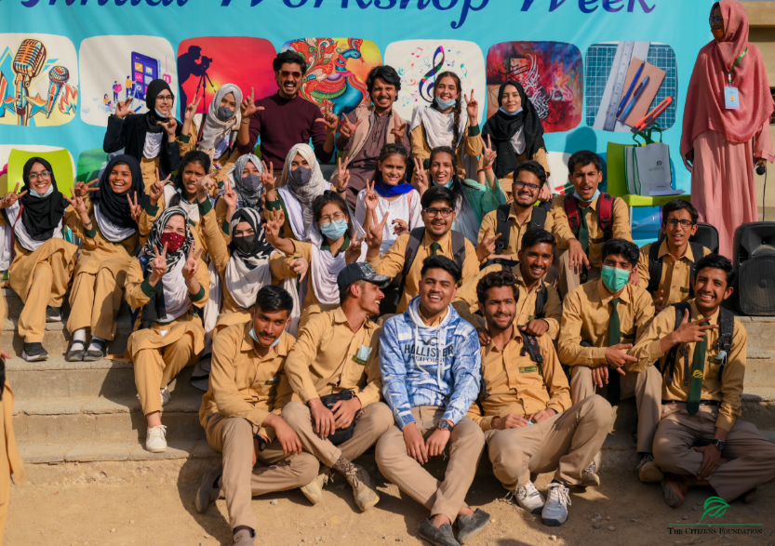evaluation and an assessment of Grit, Academic Strength, Clarity of Thought, and Conditions Framework. Throughout their university tenure, the Alumni Pathways team actively monitors and supports the progress of these students. Funds for the next term are processed only after verifying a student's GPA for the current term, ensuring accountability and timely intervention.

In its commitment to student success, TCF adopts a proactive approach. Students scoring below 2.2 are placed on probation, accompanied by verbal and written warnings. For those scoring below 2.0, a senior member from the Alumni Pathways team personally meets with the student to understand and address the reasons behind their academic challenges.

The organization firmly believes that its responsibility extends beyond providing financial aid; it strives to be a guiding force that nurtures the potential within each student. By offering continuous support and assistance, TCF aims to help its alumni overcome obstacles, stay on track, and fulfill their educational aspirations. Together, TCF and its alumni pave the way for a brighter future, empowering these deserving individuals to realize their dreams and contribute positively to society.

**Impact**

TCF students are from low-income backgrounds. Being able to attend and complete university is a life-changing experience for them, their families, and even their communities. Nadeem Hussain, a TCF school alumnus, works on public education reforms as a World Bank employee. Alumnus Anum Fatima designed a micro-lending program during an internship in Washington, DC and is now implementing it in her village. TCF alumni also give back to TCF by participating in their mentorship and other programs for current TCF students.

**Funding Request**

$500,000 will allow us to support an estimated 700+ TCF students for the year 2023-24. Currently, we are sharing a sample list with the annual cost of 304 such students who are eligible for scholarship. Every quarter we add more deserving students to the pool who need support. Accordingly, we can update you on the list as well which will include new students added to the pool and will have some students removed who are in their final years and graduate respectively. Every year with your continuous support we can help cover the annual degree cost for these students and help them complete their entire 4-5 year degree.

**Reporting Timeline**

TCF will be sharing annual reports on your annual support on the below timelines:

31st August 2024 – for the period July 2023 to June 2024

In each report, TCF will share the below update regarding the scholarships support:

|  |  |  |  |  |  |  |
| --- | --- | --- | --- | --- | --- | --- |
| **S. NO.** | **STUDENT** | **UNIVERSITY** | **ACADEMIC DISCIPLINE** | **CURRENT SEMESTER** | **AVG.SGPA** | **LGPA** |
| 1 |  |  |  |  |  |  |
| 2 |  |  |  |  |  |  |